🏭 Industrial Factory Pitch
Utility-Grade Automation for Large-Scale Manufacturing (7–20+ M SAR)
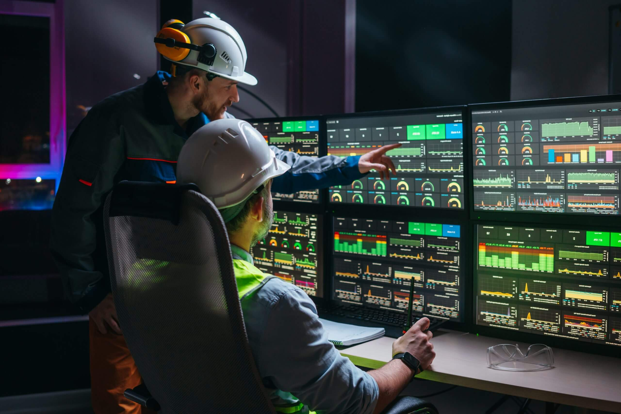

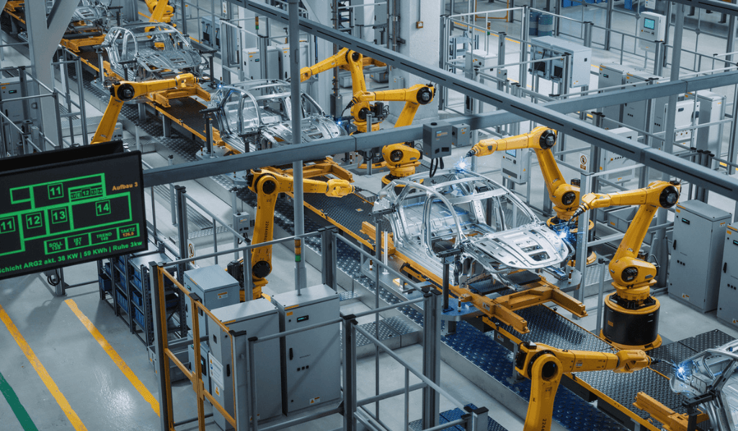
4

Executive Summary
Industrial factories today face mounting pressure to increase throughput, reduce unplanned downtime, and control energy costs—all while integrating diverse OEM equipment and legacy systems.
Mohammed Al-Ojaimi Energy Services – Automation Department delivers utility-grade factory automation platforms that provide real-time operational intelligence, built with the same rigor used to operate national power grids.
We don’t automate machines only; we automate factory operations.

The Problem We Solve
Most large factories suffer from:
- Fragmented automation islands (PLC-by-PLC visibility)
- Limited production transparency beyond the line level
- Reactive maintenance driven by alarms, not data
- High energy losses and poor power quality insight
- BMS-style systems that do not scale for industrial operations
These issues translate directly into lost OEE, higher OPEX, and operational risk.

Our Industrial Automation Approach
We design plant-wide and multi-plant automation architectures that unify production, utilities, and energy systems into a single operations platform.
Core Principles
- Reliability first (redundancy, failover, deterministic behavior)
- Open architecture (vendor-agnostic, future-proof)
- Operations intelligence, not just monitoring
- Lifecycle engineering, not one-off projects

Solution Architecture
At the heart of our solution is an enterprise-grade SCADA and operations platform built on COPA-DATA zenon, integrated with existing PLCs, DCS, drives, analyzers, and energy meters.
Typical Scope
- Plant-wide SCADA & historian
- Production line integration (multi-OEM)
- Energy & power quality monitoring
- OEE & performance analytics
- Alarm management & rationalization
- OT network design & virtualization
- Central factory command center

Key Use Cases
🔹 Production & OEE Optimization
- Real-time line performance visibility
- Bottleneck detection
- Shift-based and batch-based KPIs
- Downtime root-cause analysis
🔹 Energy & Utilities Management
- Electrical load monitoring & peak shaving
- Compressed air, steam, water monitoring
- Power quality & harmonics analysis
- Cost-per-unit production metrics
🔹 Predictive & Condition-Based Maintenance
- Asset health indicators
- Early fault detection
- Reduced reactive maintenance
- Optimized spare parts strategy

Business Value (C-Level View)
Impact Area | Typical Result
OEE Improvement | +5–12%
Energy Cost Reduction | 8–15%
Unplanned Downtime | −30–50%
Maintenance Cost | −20–30%
Decision Response Time | Minutes instead of hours
The automation platform pays for itself through measurable operational gains.

Why Al-Ojaimi Automation
Unlike traditional industrial integrators:
- We bring utility-grade engineering discipline
- We design systems to operate 24/7 for decades
- We understand power, networks, cybersecurity, and redundancy
- We act as a single accountable automation partner

Project Profile
- Typical Budget: 7 – 20+ Million SAR
- Project Duration: 9–18 months
- Engagement Models: EPC / PMC / Direct Owner
- Industries: FMCG, Food & Beverage, Cement, Steel, Chemicals, Industrial Zones

Our Commitment
We commit to:
- Engineering excellence
- Operational continuity
- Scalable, future-ready systems
- Long-term partnership—not transactional projects

Call to Action
If your factory is moving toward:
- Higher production volumes
- Energy cost control
- Multi-line or multi-plant visibility
- Industry 4.0 readiness
We are ready to engineer the backbone of your digital factory.

